Scoop
# Source: AI Source: Provided by: [Data Path: Persons Table -> ID Column: 1, Name_En Column: Motasem Essam] -> From: [ChatGPT] on [1/26/2026]
Scoop is a lightweight package manager for Windows, designed specifically for developers who want a simple, no-admin, no-GUI way to install command-line tools and apps.

🥤 What Scoop Does:
# Source: AI Source: Provided by: [Data Path: Persons Table -> ID Column: 1, Name_En Column: Motasem Essam] -> From: [ChatGPT] on [1/26/2026]
- Installs software in your user directory (no admin rights needed)
- Fetches tools like Git, Node.js, Python, curl, etc.
- Automatically sets the PATH for you
- Keeps things clean and portable

✅ Why Use Scoop?
# Source: AI Source: Provided by: [Data Path: Persons Table -> ID Column: 1, Name_En Column: Motasem Essam] -> From: [ChatGPT] on [1/26/2026]
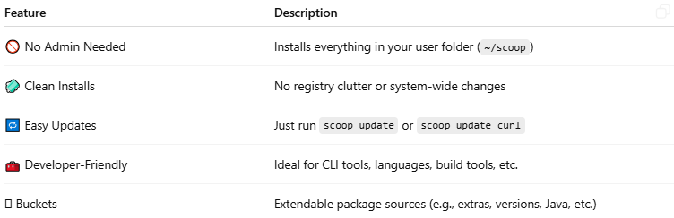

Feature | Description
🚫 No Admin Needed | Installs everything in your user folder (~/scoop)
🧼 Clean Installs | No registry clutter or system-wide changes
🔁 Easy Updates | Just run scoop update or scoop update curl
🧰 Developer-Friendly | Ideal for CLI tools, languages, build tools, etc.
🪜 Buckets | Extendable package sources (e.g., extras, versions, Java, etc.)

📦 Example Scoop Commands
# Source: AI Source: Provided by: [Data Path: Persons Table -> ID Column: 1, Name_En Column: Motasem Essam] -> From: [ChatGPT] on [1/26/2026]
✅ Install Scoop (1-time setup):
Open PowerShell (as normal user) and run:
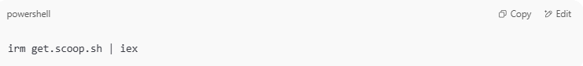
irm get.scoop.sh | iex

📥 Install a Tool:
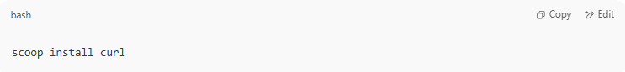
scoop install curl

🔄 Update a Tool:
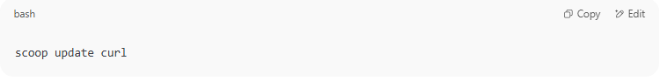
scoop update curl

🔁 Update All:
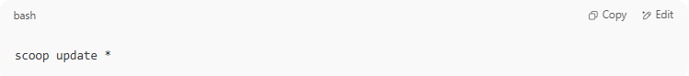
scoop update *

🔍 Search for a Tool:
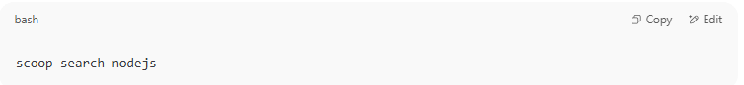
scoop search nodejs

❌ Uninstall:
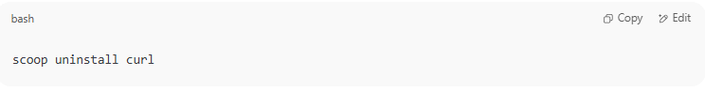
scoop uninstall curl

📁 Where Does It Install?
# Source: AI Source: Provided by: [Data Path: Persons Table -> ID Column: 1, Name_En Column: Motasem Essam] -> From: [ChatGPT] on [1/26/2026]
Scoop installs tools into:
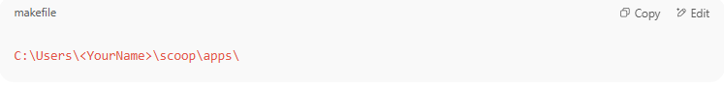
C:\Users\<YourName>\scoop\apps\

It adds them to your user’s PATH automatically, so you can run tools from any terminal.

🧱 Buckets in Scoop (Optional)
# Source: AI Source: Provided by: [Data Path: Persons Table -> ID Column: 1, Name_En Column: Motasem Essam] -> From: [ChatGPT] on [1/26/2026]
Buckets are like add-ons with more apps:
Add-ons are optional features, tools, or extensions that you can add to a main system or app to increase its functionality.
Think of them like: "Extra attachments you can snap onto a base tool to do more things."

scoop bucket add extras
scoop install vscode
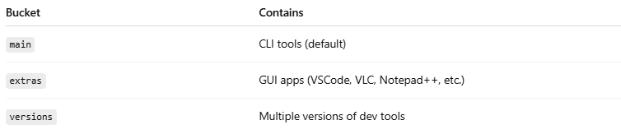

Bucket | Contains
main | CLI tools (default)
extras | GUI apps (VSCode, VLC, Notepad++, etc.)
versions | Multiple versions of dev tools

🧠 Scoop vs Winget vs Chocolatey
# Source: AI Source: Provided by: [Data Path: Persons Table -> ID Column: 1, Name_En Column: Motasem Essam] -> From: [ChatGPT] on [1/26/2026]
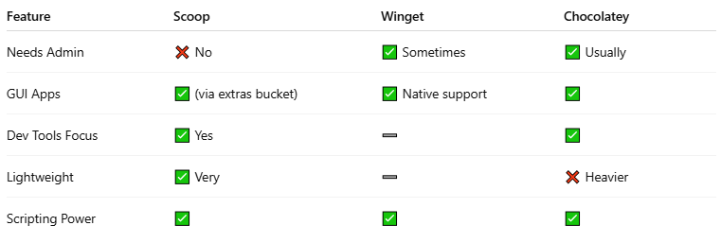

Feature | Scoop | Winget | Chocolatey
Needs Admin | ❌ No | ✅ Sometimes | ✅ Usually
GUI Apps | ✅ (via extras bucket) | ✅ Native support | ✅
Dev Tools Focus | ✅ Yes | ➖ | ✅
Lightweight | ✅ Very | ➖ | ❌ Heavier
Scripting Power | ✅ | ✅ | ✅

